About two unconventional projection methods

Abstract. In the paper, there are presented four selected projection methods, 2 of which are unconventional, and their analytic representations that provide mathematical formulas for computer processing. Views of simple objects in different types of selected projection methods are illustrated, central, parallel and quadratic projection, and projection through cubic parabolas.

Key words: linear projection, central projection, parallel projection, quadratic projection, projection through cubic parabolas

1. Generally about projection
Let ρ be a regular surface in the extended Euclidean space ∞E³.
Regular mapping Π of the space ∞E³ onto the surface ρ is called a projection, when it is defined in the following way.
Let S be a system of curves with properties:
- one and only one curve s^{X}, such that s^{X} ∈ S is passing through any point X ∈ ∞E³.
- any curve s^{X} ∈ S has one and only one common point S with the surface ρ.
Surface ρ is called projection surface, curve s^{X} is the projecting curve of the point X , point X’ is the image of the point X (view of the point X), while X’ = Π(X), X’∈ρ . D(Π) is the domain of definition of the projection Π, so it is the set of all points $X∈$ ∞E³, which have their on the projection surface ρ.
The projection is determined by the projection surface ρ and by the system of projecting curves. The choice of the projection surface ρ and the system of projecting curves gives different types of projections.
In the following we are interested in those projections exclusively, where the projection surface ρ is a projection plane

2. Classification of the projection methods with respect to the system of projecting curves

  - System of the projecting curves is created by lines
- Central projection
Projection is determined by choosing the projection plane ρ and the point S – centre of the projection. The domain of definition is D(Π) = ∞E³ – {S}.
Because generally the view of a line not passing through the centre S is again a line, this projection method is a linear mapping.
- Parallel projection
Projection is determined by choosing the projection plane ρ and the point at infinity ∞S – projection direction. The domain of definition is D(Π) = ∞E³ – { ∞S}. Projection in this case is linear too, because generally the view of a line not coincident with the point ∞S is again a line.
- Quadratic projection
Let a, b be two skew lines in the space ∞E³. The system S of the projecting curves is created by lines, which are intersecting to both given skew lines a, b. The projecting line of the point X of the space ($X∉a ∧ X∉b$) is the line intersecting two skew lines a, b and located in the point X .
The domain of definition is D(Π) = ∞E³ – {a ∪ b }.
Projection method introduced in this way is called quadratic projection [1]. The view of a line in the general case is a quadratic curve (conic section).
Quadratic projections can by classified as above:
i) both lines a, b are real lines, and we speak about the quadratic projection of the first type
ii) line a is a real line and line b is a line at infinity, and the quadratic projection of the second type is determined.

  - System of the projecting curves is created by cubic parabolas – projection through cubic parabolas

Projection through cubic parabolas is determined by choosing the projection plane ρ, the point S and the line t through S (S ∈ t) orthogonal to the projection plane ρ;. Line t is a common tangent to all cubic parabolas forming the system S of projecting curves and sharing the point S as a point of inflection.

3. Analytic representations of selected projections
To construct view of a figure under quadratic projection or projection through cubic parabolas is not an easy task, which can be realised only by means of computer graphics. Necessary mathematical formulas for the computer processing of the figure views in separate selected projection methods are presented in this chapter.
In the Euclidean space E³ (E³ ⊂ ∞E³), let us choose a Cartesian coordinates system <O, x, y, z> so that the projection plane ρ will be the plane yz. Let the original point X of the projected object have coordinates $X=\left[x,y,z\right]$ and let the point $X^{'}=\left[x´ , y\text{´,} z´\right]$ be its view.

3.1. System of the projecting curves is created by lines
It is evident, that the equations of this type of projection are
$x^{'}=0 , y^{'}=\frac{y s_{1}−x s_{2}}{s_{1}} , z^{'}=\frac{z s_{1}−x s_{3}}{s_{1}}$ , $s_{1}≠0$, (1)
where $s=\left(s_{1}, s_{2}, s_{3}\right)$ is the direction vector of projecting lines of points from the domain of definition D(Π) (see paragraph 2).
Let the curve k have parametric equations
$x=x(u) , y=y(u) , z=z(u) , u∈ I, I⊂R$. (2)
Parametric equations of its view k´ are
$x^{'}=0, y^{'}=\frac{y(t) s_{1}−x(t) s_{2}}{s_{1}} , z^{'}=\frac{z(t) s_{1}−x(t) s_{3}}{s_{1}} , t∈ I \text{.}$ s₁ ≠ 0 (3)
- Central projection (Fig. 1)
Let the point $S=\left[x_{S}, y_{S}, z_{S}\right]$ be the centre of projection, than $s=\left(x−x_{S}, y−y_{S}, z−z_{S}\right)$ is the direction vector of the projecting line s^{X} of the points X ∈ D(Π). From the equation (1) we receive, after substituting the coordinates of the vector s,
analytic representation of the central projection in the form
$x^{'}=0 , y^{'}=\frac{y x_{S}−x y_{S}}{x_{S}−x} , z^{'}=\frac{z x_{S}−x z_{S}}{x_{S}−x}$, x_{S} – x ≠ 0 (4)
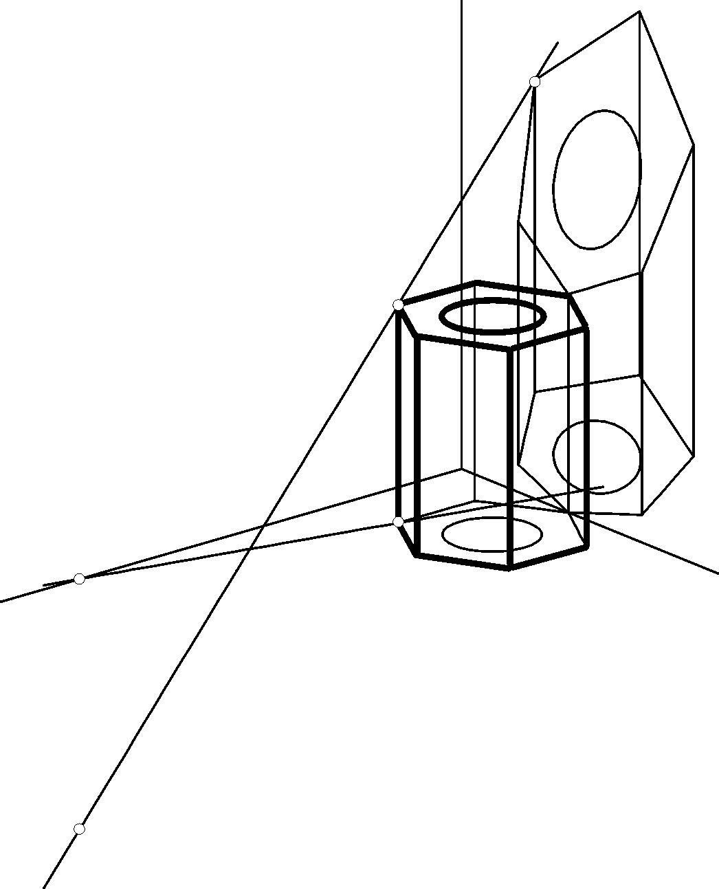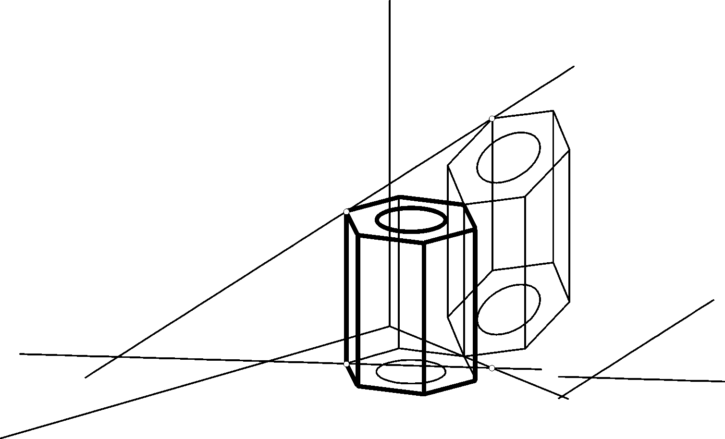
X₁
Fig. 1 Fig. 2

X´

X

s^{X} X´

S₁ X₁ X
s₁^{X}

s^{X}
S s₁^{X}

Parallel projection (Fig. 2)
Let the direction of the parallel projection be determined by a non-zero vector $s=\left(s_{1}, s_{2}, s_{3}\right)$, than equations (1) are analytic representations of the parallel projection and equations (3) are parametric equations of the view k´ of a curve k .

Quadratic projection
Vector $s=\left(s_{1}, s_{2}, s_{3}\right)$ is the direction vector of lines intersecting two skew lines a, b, which are the projecting lines of the quadratic projection. s = a x b , where $a=\left(a_{1}, a_{2}, a_{3}\right)$ is the normal vector to the plane α = Xa and $b=\left(b_{1}, b_{2}, b_{3}\right)$ is the normal vector to the plane β = Xb in the case of the first projection type, while β = X∞b in the case of the second projection type.
In the case of the first type (Fig. 3), let the line a be determined by point $A=\left[x_{A}, y_{A}, z_{A}\right]$ and by the direction vector $s_{a}=\left(x_{a}, y_{a}, z_{a}\right)$ and line b by the point $B=\left[x_{B}, y_{B}, z_{B}\right]$ and the direction vector $s_{b}=\left(x_{b}, y_{b}, z_{b}\right)$. Normal vectors a and b to the planes α a β are
$a=\left(z_{a}y_{p}−y_{a}z_{p}, −z_{a}x_{p}+x_{a}z_{p}, y_{a}x_{p}−x_{a}y_{p}\right)$,
$b=\left(z_{b}y_{q}−y_{b}z_{q}, −z_{b}x_{q}+x_{b}z_{q}, y_{b}x_{q}−x_{b}y_{q}\right)$,
while coordinates of vectors = (x_{p}, y_{p}, z_{p}) = AX and q = (x_{q}, y_{q}, z_{q}) = BX can be easily determined
$p=\left(x−x_{A}, y−y_{A}, z−z_{A}\right)$,
$q=\left(x−x_{B}, y−y_{B}, z−z_{B}\right)$.
The direction vector s of the lines s^{X} intersecting two skew lines of point X has coordinates
$s=\begin{aligned}\left((z_{a}x_{p}−x_{a}z_{p})(y_{b}x_{p}−x_{b}y_{p})−(y_{a}x_{p}−x_{a}y_{p})(z_{b}x_{p}−x_{b}z_{p}) | \right)\left(−(z_{a}y_{p}−y_{a}z_{p})(y_{b}x_{q}−x_{b}y_{q})+(y_{a}x_{p}−x_{a}y_{p})(z_{b}y_{q}−y_{b}z_{q}) | \right) \\ \end{aligned}$. (5)
In the case of the second projection type of a quadratic projection (Figure. 4) the line b is a line at infinity in the space ∞E³. This ideal line is represented by an arbitrary plane β from the system of parallel planes incident with line ∞b.
When the two non-zero vectors $q=\left(x_{B}, y_{B}, z_{B}\right)$ and $s_{b}=\left(x_{b}, y_{b}, z_{b}\right)$ determine the plane β, then vector (5) is a direction vector of a line intersecting two skew lines, which is the projecting line s^{X} of the point X. It is clear that the projecting lines are parallel to the plane β .
Analytic representation of the quadratic projection can be derived after substituting coordinates of the vector s (5) to the equations (1)
$x^{'}=0 , y^{'}=\frac{y s_{1}−x s_{2}}{s_{1}} , z^{'}=\frac{z s_{1}−x s_{3}}{s_{1}}$, s₁ ≠ 0 .
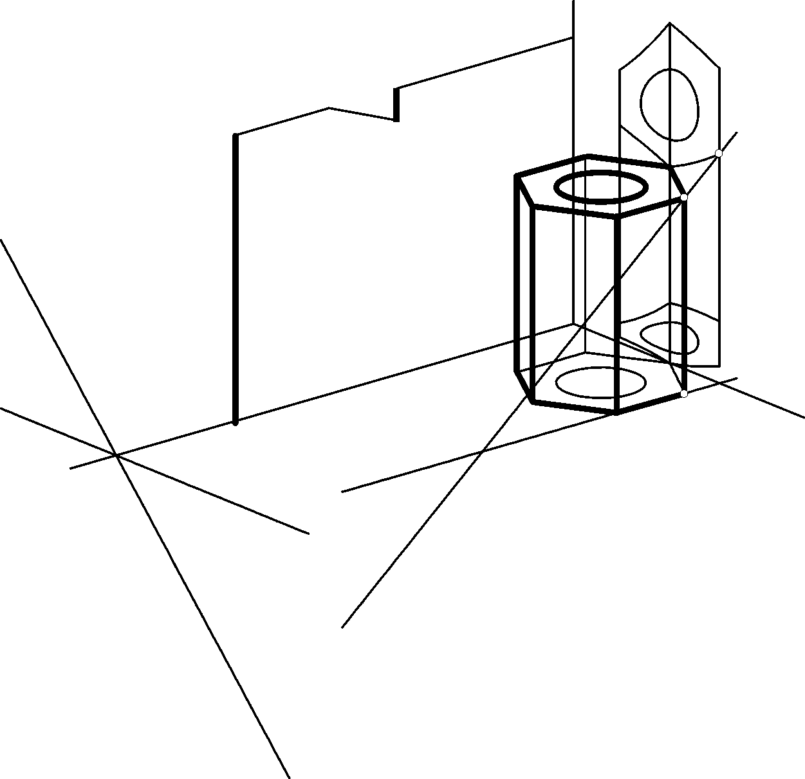

X´

X

s^{X}

a b₁ b
X₁
a₁ s₁^{X}
A=A₁

β X´
X

a

∞b₁ X₁

s₁^{X}
s^{X}

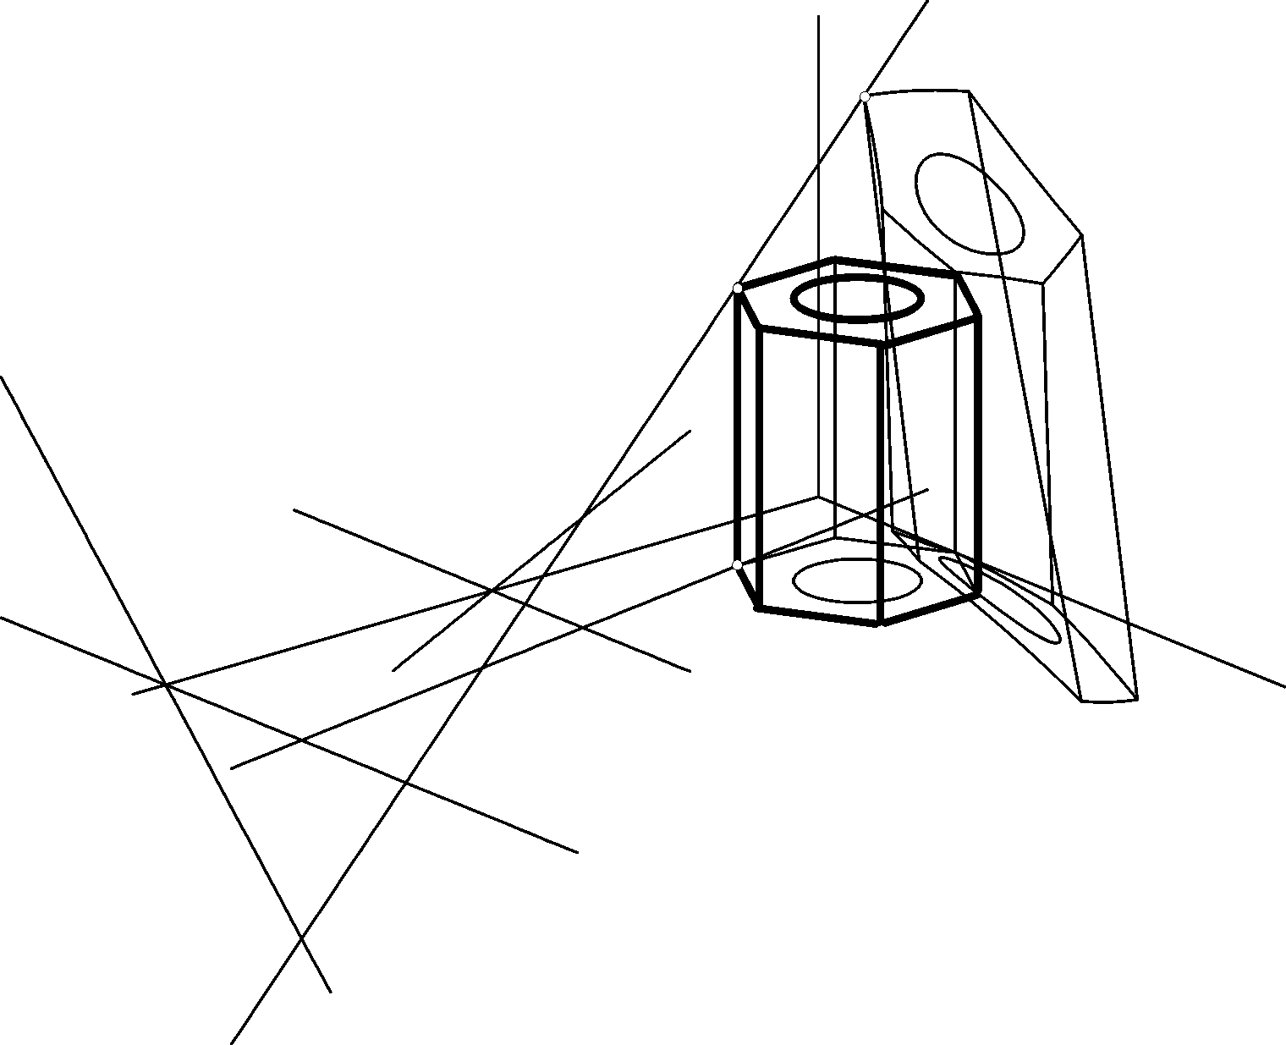
B=B₁
Fig. 3 Fig. 4
A=A₁
a₁

3.3. Projection through cubic parabolas (Fig. 5)
Analytic representation of projection through cubic parabolas, which have the common point $S=\left[b, 0, 0\right]$ and common tangent line orthogonal to the projection plane ρ (ρ = yz), forms a system of equations
$x^{'}=0 , y^{'}=\frac{−b^{3}y}{(x−b)^{3}} , z^{'}=\frac{−b^{3}z}{(x−b)^{3}}$, x – b ≠ 0 .
derived in [2].
It is clear that parametric representation of the view k´ of a curve k (2) is
$x^{'}=0, y^{'}=\frac{−b^{3}y(t)}{{\left(x(t)−b\right)}^{3}} , z^{'}=\frac{−b^{3}z(t)}{{\left(x(t)−b\right)}^{3}} , t∈ I$, x(t) – b ≠ 0
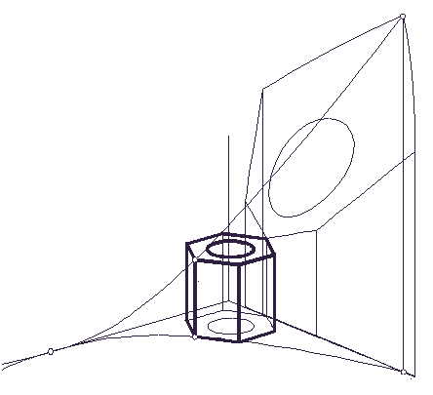
X´

X

s^{X}

X₁
s₁^{X}
X₁´
S = S₁
Fig. 5

V´
H´
V´ V´
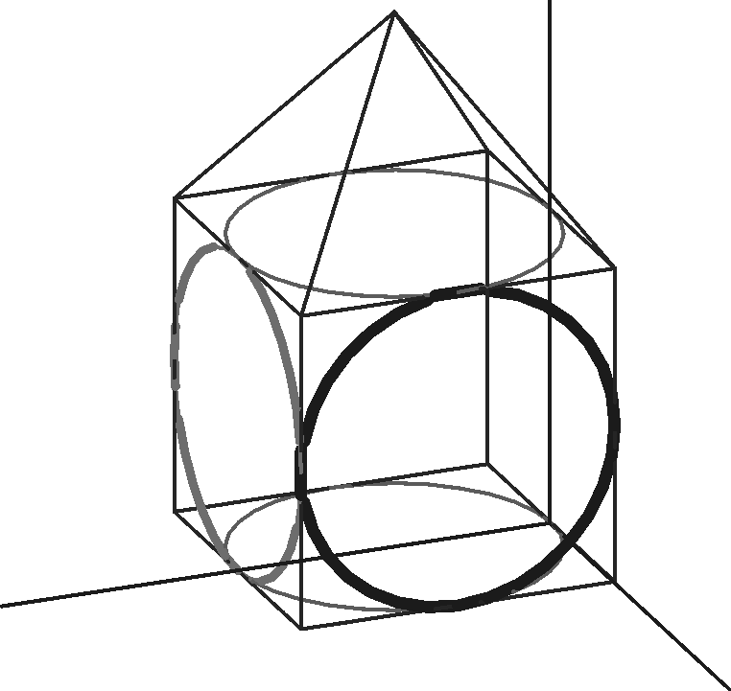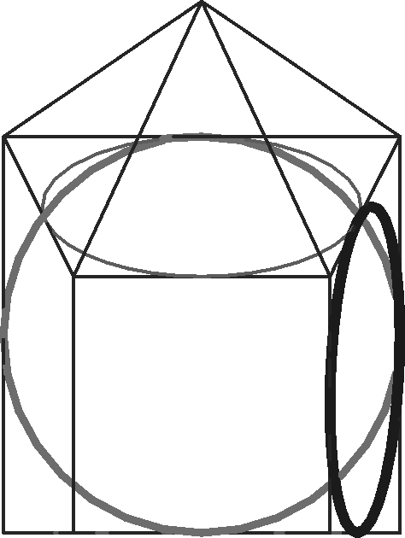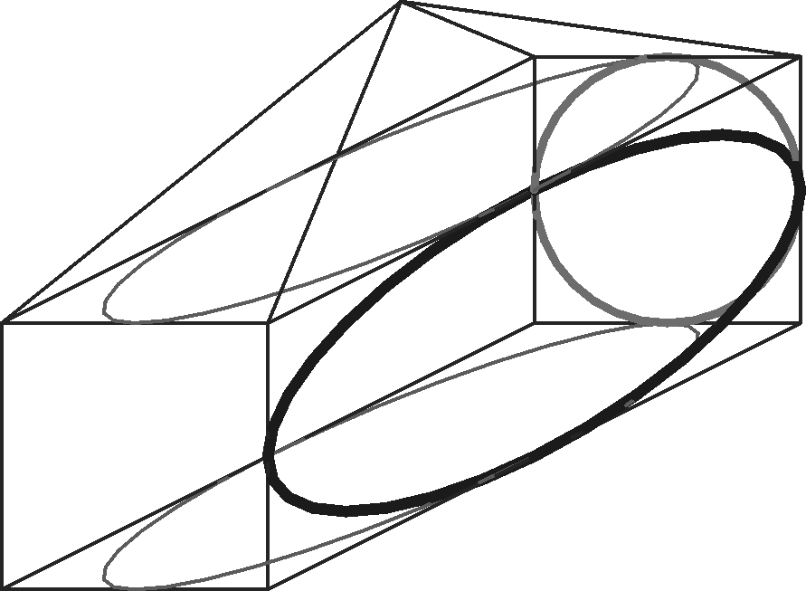
B
C´ B´ A´ C´ B´
A
H
H´
A´
C
D
E F
G
G´ F´ G´ F´

Fig. 6 Fig. 7 Figure 8

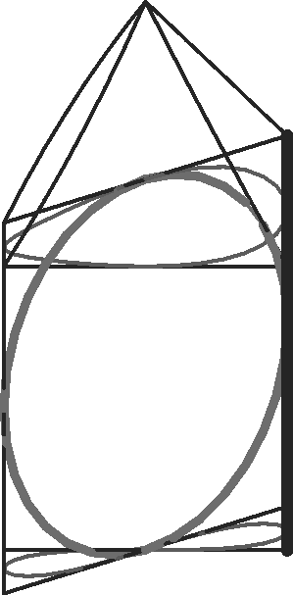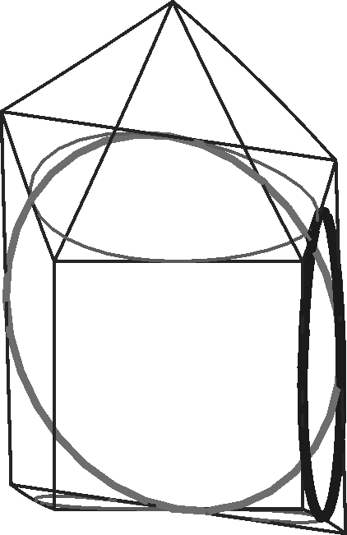
A´
V´
V´
A´
C´ B´
H´
H´
C´ B´
G´ F´
G´ F´
Fig. 9 Fig. 10

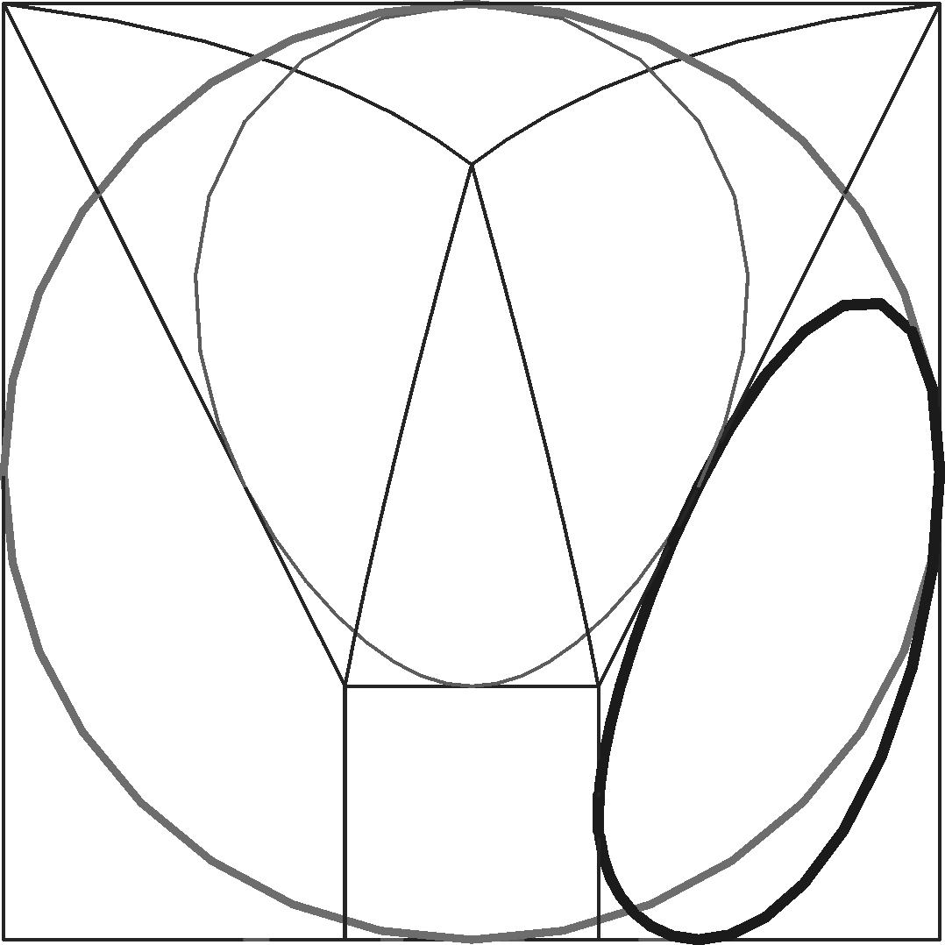
V´
H´
C´ B´ A´
G´ F´

Fig. 11
In the figures 6 – 11, there are illustrated views of the simple wireframe model under axonometric projection, and under the above presented projections, i.e. parallel, central and quadratic projection and under the projection through cubic parabolas. Model is composed from cube ABCDEFGH and regular pyramid EFGHX. Two sides of the cube are located in the coordinate planes ( ABCD ⊂ xy, BCGF ⊂ yz ), circles are drawn in four sides of the cube to make the model more readable with respect to the visibility, and several vertices of the figure are marked for the sake of an easier orientation in the views.
References
[1] SZARKOVÁ D., MALEČEK K. Projections and their Classification. In Mechanical Engineering 2000, Proceeding of presented papers, Part II, Bratislava: SjF STU, 2000. ISBN 80-227-1436-4, p. 12-64 – 12-67.
[2] SZARKOVÁ D., MALEČEK K. Premietanie kubickými parabolami. In Mechanical Engineering 2001, Proceeding of presented papers, Part III, Bratislava: SjF STU, 2001. ISBN 80-227-1616-2, p. 708 – 711.
[3] VELICHOVÁ D. Geometrické modelovanie, matematické základy. Vydavateľstvo STU Bratislava, 2005. ISBN 80-227-2179-4.

RNDr. Dagmar Szarková
Department of Mathematics
Mechanical Engineering Faculty
Slovak University of Technology in Bratislava
Nám slobody 17, 81231 Bratislava, SR
e-mail: dagmar.szarkova@stuba.sk

